# Usability Testing

**Old Reddit (https://old.reddit.com)**

**Product Description**

*Reddit is an American social news aggregation, web content rating, and discussion website. Registered members submit content to the site such as links, text posts, images, and videos, which are then voted up or down by other members*.

- Wikipedia (<https://en.wikipedia.org/wiki/Reddit>)

Reddit is divided into ‘subreddits’, communities on the website focused on one particular topic, where every post is related to that topic.

Figure 2: A text post in the /r/unpopularopinion subreddit.

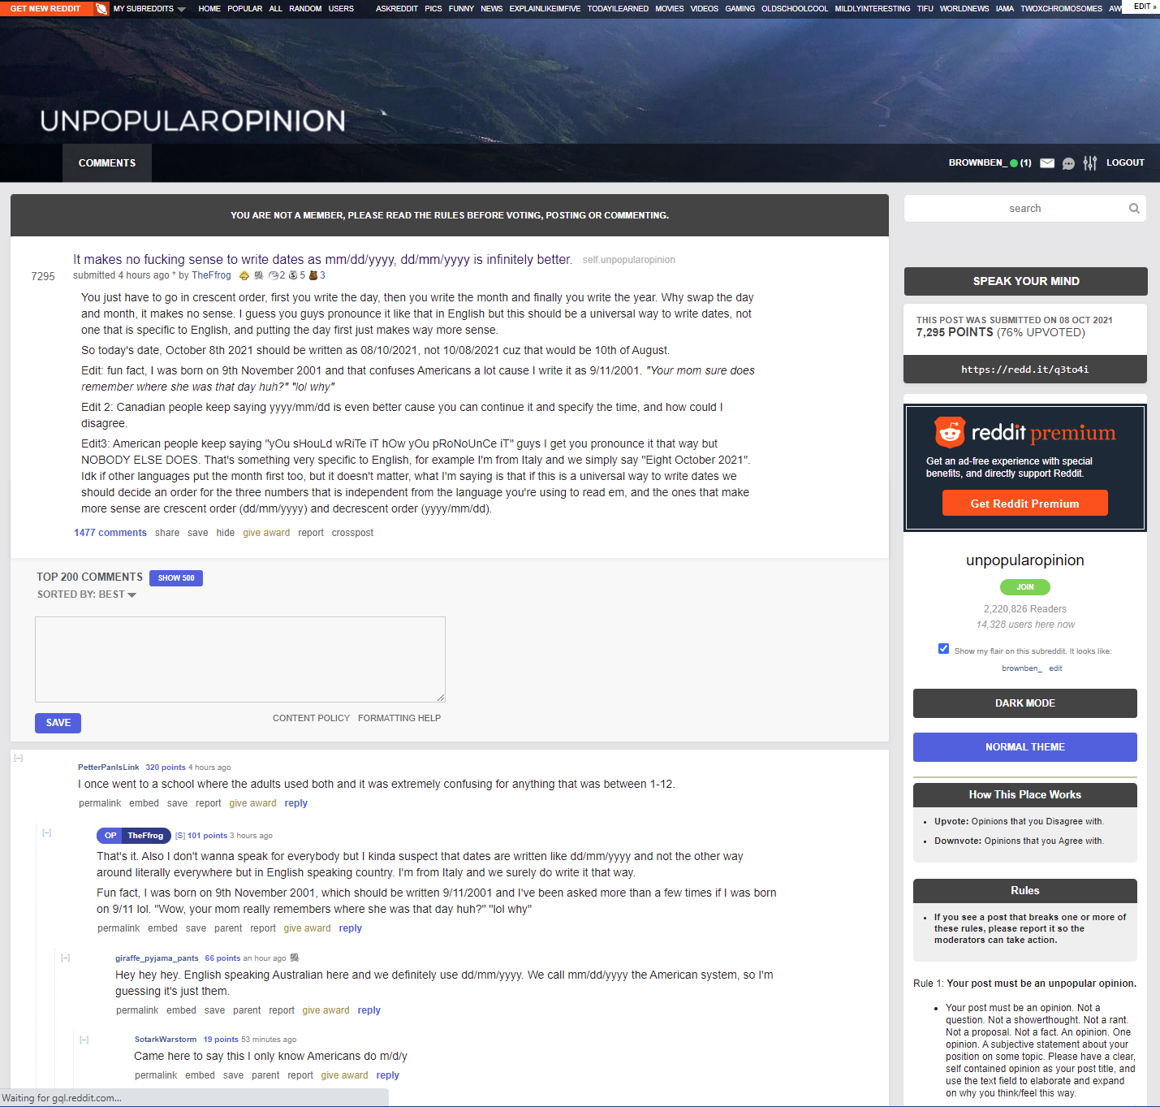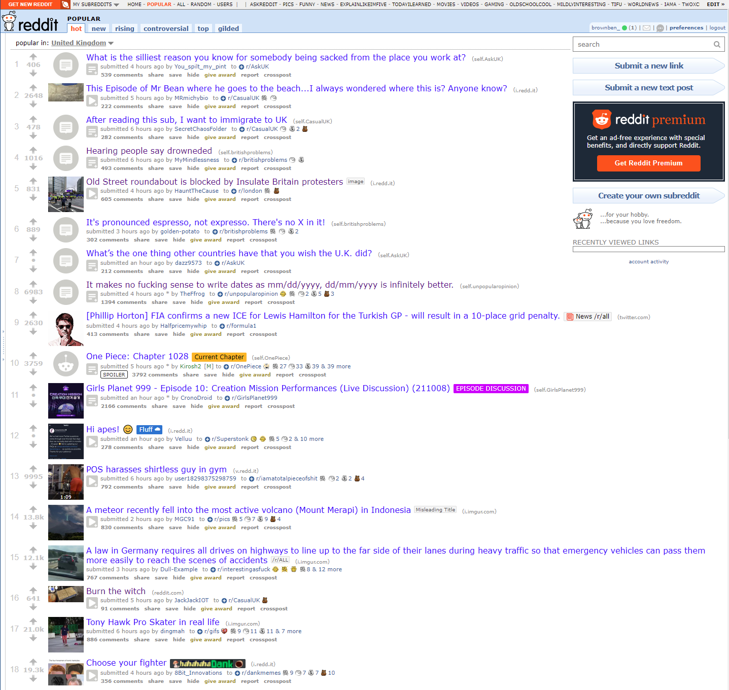

Figure 1: Main page of Reddit, paginated scroll.

**Identified Issues (Master List):**

1. Hard to tell where you are - ‘home’ is a tiny text at the top
   * #1: Visibility of system status
2. Hard to tell separate items apart
   * #5: Error prevention
3. Hard to find content which is relevant to you without prior knowledge of navigation
   * #4: Consistency and standards (external)
4. ‘Gilded’ posts, karma - new users wouldn’t understand this
   * #2: Match between real-world and system
5. Each subreddit’s individual UI breaks internal consistency
   * #4: Consistency and standards (internal)
6. Documentation - specific word usage to even find it: ‘wiki’ may not be understandable to new users
   * #10: Help and documentation, #2: Match between real-world and system
7. Messaging icons don’t distinguish their use
   * #2: Match between real-world and system
8. Inconsistent verb usage - where are those ‘subscribe’ and ‘unsubscribe’ buttons?
   * 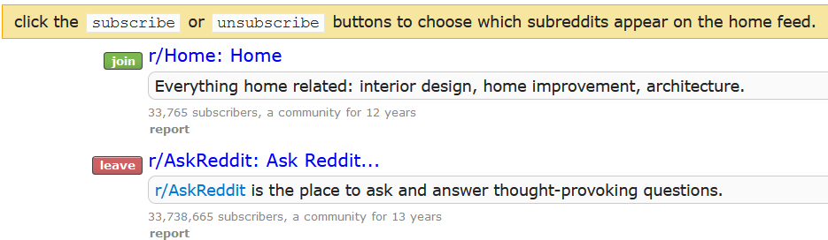
   * #4: Consistency and standards (internal)
9. No ‘cancel’ options anywhere when creating posts/subreddits
   * #3: User control and freedom
10. All links are very small
    * #6: Recognition rather than recall
11. Logical stuff isn’t grouped together (e.g., login is split by the search bar)
    * #6: Recognition rather than recall
12. Colour contrast doesn’t meet accessibility guidelines
    * #1: Visibility of system status
13. Since there are a lot of links, users could easily find themselves on the wrong page and the only obvious button to get out would be the home button which isn’t that that useful if the user has gone through multiple pages to get there (also some destructive actions have no undo e.g. clearing recent posts)
    * #3: User control and freedom
14. The site is not minimalist - a lot of text on one visible page
    * #8: Aesthetic and minimalist design
15. Structure not similar to other social media, so it is harder to learn for new users
    * #4: Consistency and standards (external)
16. Error message once logged in and no content added, but no instructions on how to get the content
    * #9: Help users recognize, diagnose, and recover from errors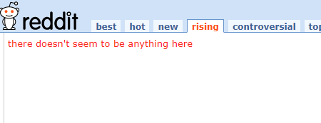
17. Lack of whitespace
    * #8: Aesthetic and minimalist design

